
Budget and Personnel
  - Team Members: Jonathan Kim, Demetrius Schank
  - Due Date: 2/11/2026

Schedule
Throughout the duration of the project, the initial planned schedule has been significantly expanded in both size and detail of the tasks. Due to the size of the Gantt Charts, references should be made to the “Appendix” to view a full print out of either chart. The initial “Spring25 Cell Imaging Gantt Chart” contained tasks limited to the scope of the Spring 2025 semester. Early in the development stage, the trajectory of the project was difficult to predict, and therefore the project’s main goals were laid out very vaguely. In this older schedule, typographical discrepancies are present in the Execution portion. All years were intended to be 2025, however some project end dates were mistakenly extended into the Spring 2026 semester.

In the newest schedule, “Spring26 Cell Imaging Gantt Chart”, the initial goals were reworked to eliminate redundancy. To accurately reflect the past schedules, a handful of the original task descriptions were not renamed. Instead, any future new tasks added to the schedule were more specific, as seen in the Spring 26 portion of the “Spring26 Cell Imaging Gantt Chart”.

Personnel
John Ahn - 3D print, can help with MATLAB
John is the manager of the Gantt chart. He enjoys designing and 3D printing, so he oversees designing a physical prototype (if the group decides to go into it). He has little background in MATLAB, so he’ll be assisting Jonathan with it.

Demetrius Schank –
Demetrius brings a strong work ethic to the team, really driving the team to think about the project as often as possible. He is detail oriented and thus needs to gather a lot of information to feel ready to tackle a project. This makes him a great candidate to be the head of research for the team. With the work the team has done so far, it is clear the team needs someone to drive the team towards a narrower focus. In this role, he is responsible for providing that tunnel focus—which datasets the team should use, and which characteristics should the team be trying to test for. He is not responsible for all the research, rather for being a pillar for the team's research.

Jonathan Kim –
Jonathan brings his experience of MATLAB coding to the table, easing the team to code in this language. While he will not be the sole coder of the team, he can be one to find methods to lead the others to do. If the group decides to go physical, he can help with wiring and electronic devices/systems.

Person | John Ahn | Jonathan Kim | Demetrius Schank
Spring25 Hours  (estimate) | 15 | 15 | 15
Fall25 Hours | 31 | 30.25 | 36.75
Total | 46 | 45.25 | 51.75

Parts and Components
MATLAB License
Made by MATLAB, with the company’s headquarters stationed in Natick, MA. Three licenses were necessary, one for each member of the group. These licenses were provided by Villanova University’s campus-wide license for MATLAB. These licenses are renewed every year by Villanova University. Without the sponsored licenses, the individual licenses could have a cost of $119-$165. Three licenses are required for this project, one for each team member.

Hardware – Windows OS
Hardware capable of running the Windows OS is manufactured by various companies. For the purposes of this assignment, the component is represented by a Windows OS laptop sold by Dell Technologies. Various Windows OS laptop devices are built and sold by Dell Technologies, each offering different capabilities and price points. A cost of $800 is estimated for a Windows OS laptop suitable for this project. Dell Technologies is headquartered in Round Rock, Texas.

Hardware – MacOS
Hardware capable of running the MacOS is manufactured by Apple Inc. Various MacOS laptop devices are built and sold by Apple Inc., each offering different capabilities and price points. A cost of $800 is estimated for a MacOS laptop suitable for this project. Apple Inc. is headquartered in Cupertino, California.

Skills and Tools
Image Processing Toolbox
The main toolbox used in our project, able to draw a mask, region of interest, and analyze multiple regions of interest to compare.

FFmpeg Toolbox
Optional toolbox used to remove duplicate frames from a video. This toolbox was used with the future goal in mind to obtain a constant time value to eventually calculate deformation rate.

K-Lite Codec Pack Standard
K-Lite Codec Pack Standard is a free collection of audio and video codecs for Windows systems that enable the playback and processing of various media formats. Codecs such as Cinepak (“cvid”) are included so that video files requiring specific decoding methods can be properly read by a system. It is used in this project to ensure that .vi and other codec-dependent video files can be processed without runtime errors, allowing deformation analysis to be performed as intended.

Budget
The budget is calculated using the worst-case cost scenario, particularly for the MATLAB license. Industry “Tool Overhead Cost” are calculated via the following criteria:

- $0.16 per kWh for Villanova PA Electricity Cost. Assume 2.25 kWh usage per hour per member.
  - Total Electricity Cost = $51.48
- $0.03 other utility costs per hour per member.
  - Total Other Utility Costs = $4.29
Industry “Salary Overhead Cost” is calculated via the following criteria:
- $25 per hour for custodial staff for used public spaces for max labor hours of a member (x2)
  - Total Custodial Cost (for 2 custodians) = $2587.50

 | Industry cost ($) | Actual cost ($)
Hardware Part Costs | 1600.00 | 0.00
MATLAB License | 1050.00 | 0.00
Tool Overhead Cost | 55.77 | 0.00
Salary Overhead Cost | 2587.50 | 0.00
Member #1 Labor Cost | 1150.00 | 0.00
Member #2 Labor Cost | 1131.25 | 0.00
Member #3 Labor Cost | 1293.75 | 0.00
Villanova’s Overhead  (federal) | 0.00 | 0.00
Total | 8868.27 | 0.00

Appendix
Due to the size of the Gantt Charts, they are inserted below so that space is not taken up in the middle of the document. Analysis comparing the two schedules is found in the “Schedule” section.

  - Spring25 Cell Imaging Gantt Chart
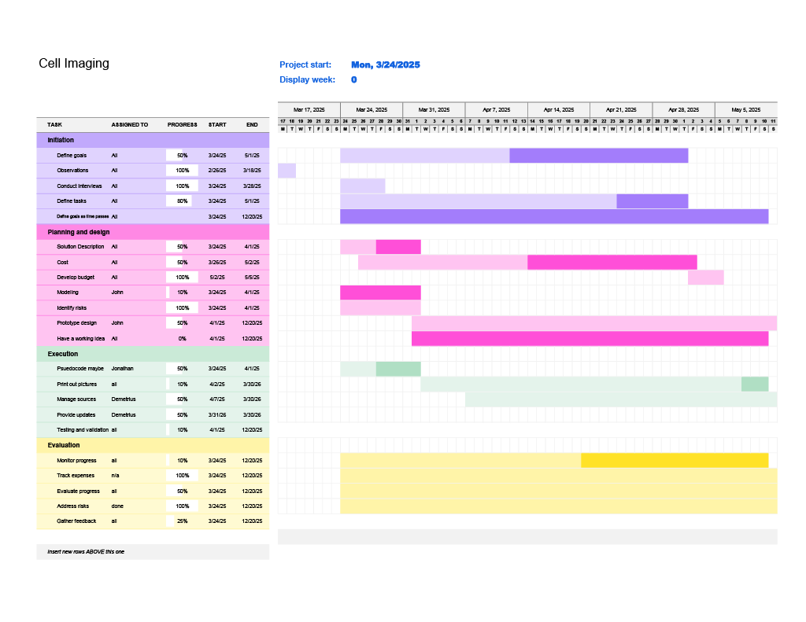

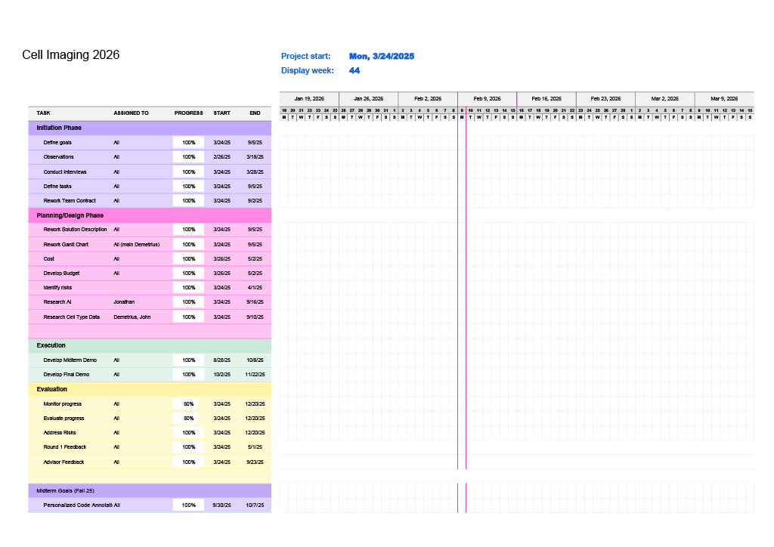
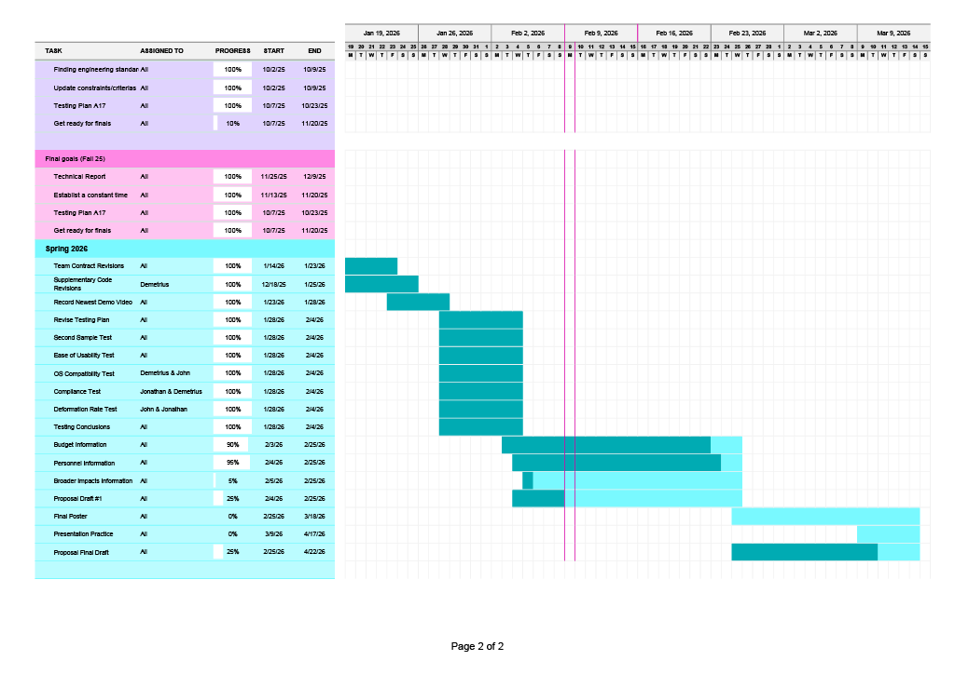
  - Spring26 Cell Imaging Gantt Chart

